John & Nicole Manley
**********@gmail.com | (519) 508-****
98 William St. Apt. 10 Stratford ON N5A 4Y1 Canada

Mr. Andrew Williams
46 General Hospital Dr.
Stratford, ON N5A 2Y6
Saturday, October 24, 2020
Dear Mr. Williams,
A dentist in Ontario created the following graph to show how helpful masks have been in slowing the second wave:
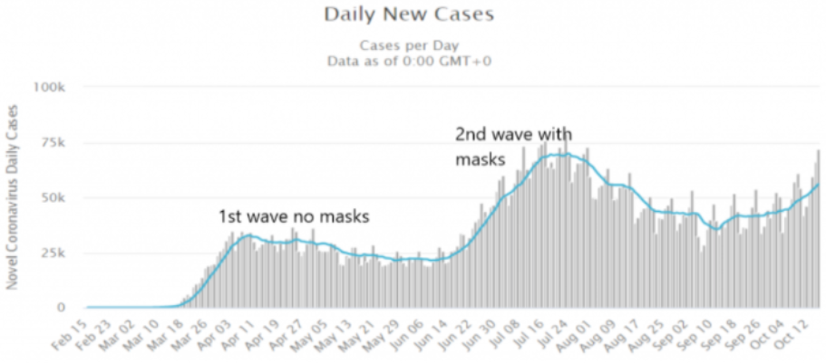
Yes, masks are truly the pinnacle of modern medicine: Fending off evil corona spirits with all the effectiveness of a lucky rabbit’s foot and a pinch of salt over the left shoulder.
More importantly, however, the above chart suggests that the second wave has more to do with increased testing rather than an increased infection rate. As Drs. Karina Reiss, PhD and Sucharit Bakdi, MD confirm in their book Corona: False Alarm?: “The more tests are performed, the more COVID-19 cases are found during the epidemic. This is the essence of a laboratory-created pandemic.”
And, of course, the number of positive test results will increase with the number of amplification cycles used in PCR testing. As The New York Times wrote: “In three sets of testing data that include cycle thresholds, compiled by officials in Massachusetts, New York and Nevada, up to 90 percent of people testing positive carried barely any virus…”
In Ontario “COVID cases” are apparently “surging,” so the fear-mongering media tells us. Yet, we are using a very high cycle threshold which would produce as many as 93% false positives. MPP Randy Hillier posed the following question to the Premier at a legislative assembly in September:
We know high false positive rates are due to high [cycle thresholds] and Canadian and world experts agree it should not be more than 25 cycles. Yet, according to the Journal of [Clinical] Virology, Ontario labs are testing samples at 38-45 cycles… When did the Premier become aware of these faulty tests and practices? And why have you done nothing to fix them since at least July?
The Premier, however, was absent; while the Health Minister dodged the question with all the grace of a newborn giraffe.
In September, The Westphalian Times queried provincial health authorities across the country asking for their cycle thresholds. Here’s what they got back:
Ontario, British Columbia, Nova Scotia, and Saskatchewan refused to share their PCR testing information. British Columbia said they did not have the ‘capacity’ to retrieve this information… Alberta and New Brunswick failed to respond to our requests at all.”
Quebec health authorities, however, reported using a 45 PCR cycle threshold. Interesting, isn’t it, that they also have so many “cases”? Maybe instead of enforcing ineffective and draconian measures such as mandatory masking, we should stop using hyper-sensitive and unapproved testing on a common-cold virus. That would be far simpler way to reduce “COVID cases” without taking away people’s freedom and bankrupting the economy.
Of course, most are not really “cases”. Even the positive ones. A COVID-19 case refers to someone with severe respiratory problems who tests positive for SARS-CoV-2. People who aren’t even aware they are infected, don’t count. At least, not in reality. However, on TV, in newspapers and in big government, anything seems possible.
In conclusion, I must reiterate that we do not consent to human right violations over a fabricated emergency. We do not consent to unscientific and harmful methods of disease control such as masking, lockdowns and social distancing. We do not consent to the use of PCR tests which are admitted by the FDA to be inadequate and unapproved for detecting a virus that has not been proven to have anything to do with symptoms attributed to COVID-19.
Those continuing to enforce corona-control measures, which are costing lives and destroying the economy, can no longer claim ignorance before the avalanche of evidence. They will be held liable and responsible. Instead of operating with these international, corporate and political agendas; please help lead society away from this self-destructive “new normal" servitude.
Sincerely,

John C. A. Manley Nicole P. Manley

